# Can2Cluster Installation Guide

*Forbes Automotive*

Contents

Can2Cluster Installation Guide 1

Product Overview 3

Wiring Installation 3

Disclaimer 5

# Product Overview

**Thank you for purchasing the Can2Cluster for Volkswagens by Forbes Automotive!**

The product is designed to take CANBUS signals from OEM ECUs – like Bosch ME7.x, EDC.x as well as aftermarket ECUs – like Haltech, EMU etc.

The device takes the signals and converts them into signals to suit analog clusters – like the MK1 & MK2. It is fully opensource and the source code can be downloaded and adjusted to suit other brands if required. Please get in touch if you need help!

Inputs:

* RPM (from CAN)
* Speed (from VSS via. ECU, over CAN)
  + *Optional GPS or DSG setup available too
* EML (from CAN)
* EPC (from CAN)

Outputs:

* RPM (12v pulse or typical ignition coil)
* Speed (12v pulse)
* EML (12v to LED)
* EPC (12v LED)
* Needle sweep (*if activated in firmware)

# Wiring Installation

**Wiring the new module in is easy! You’ll need access to:**

* CAN BUS (near the OEM ECU)
  + CAN High (Orange/Black stripe)
  + CAN Low (Orange)
* 12v Ignition (Red)
* Ground (Brown)

Use the outputs as per the diagram below to suit your installation. Final firmware update may be required to suit final requirements!

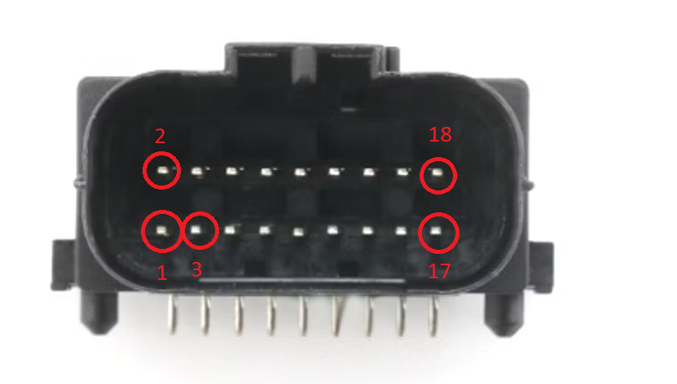

|  |  |  |
| --- | --- | --- |
| **Pin Number** | **Basic Detail** | **Comments** |
| 1 | 12v Ignition (K15) | Switched power (for waking up the module) |
| 2 | Reverse | Via. Internal relay - 3A max. - for DSG |
| 3 | Ground | Module ground - to chassis etc |
| 4 | N/A | Not used |
| 5 | CAN L | CAN Low from ECU |
| 6 | N/A | Not used |
| 7 | CAN H | CAN High from ECU |
| 8 | Paddle down | Steering wheel paddle down - input to ground - for DSG |
| 9 | N/A | Not used |
| 10 | Paddle up | Steering wheel paddle up - input to ground - for DSG |
| 11 | N/A | Not used |
| 12 | EPC | 12v to EPC |
| 13 | N/A | Not used |
| 14 | EML | 12v to EML |
| 15 | N/A | Not used |
| 16 | RPM | 12v to cluster RPM (>MK2 / not high voltage) |
| 17 | RPM | MK1 / MK2 to cluster RPM (high voltage!) |
| 18 | Speed | 12v pulsed speed |

# Disclaimer

DISCLAIMER:

**Forbes Automotive** is not responsible for any damage or loss that may occur to your vehicle or its contents during or after the installation of the OpenHaldex T4 Module. By agreeing to use our product, you acknowledge that you have read and understand this disclaimer and agree to release Forbes Automotive from any liability for damages or losses.

LIMITATION OF LIABILITY:

In no event shall **Forbes Automotive** be liable for any direct, indirect, incidental, consequential, special, or punitive damages arising out of or in connection with the installation of the OpenHaldex T4 module, whether in contract, tort, strict liability, or any other legal theory.

This product is to be used in off-road applications only.

WARRANTY DISCLAIMER:

**Forbes Automotive** makes no warranties, express or implied, concerning the product, including but not limited to any warranties of merchantability or fitness for a particular purpose.

OTHER TERMS AND CONDITIONS:

By agreeing to use our services, you also agree to comply with any additional terms and conditions that may be provided to you by **Forbes Automotive** in connection with the product.